The Role of Object Affordances and Center of Gravity in Eye Movements Towards Isolated Daily-Life Objects

Lotje van der Linden, Sebastiaan Mathôt and Françoise Vitu
Aix-Marseille University, CNRS, LPC UMR 7290, Marseille France

Corresponding author:
Lotje van der Linden
Laboratoire de Psychologie Cognitive (LPC)
CNRS, Aix-Marseille Université, UMR 7290
Centre St Charles, Bâtiment 9, Case D
3 place Victor Hugo
13331 Marseille, cedex 03
e-mail address: l.vanderlinden@cogsci.nl
telephone number: +33 4 13 55 09 66

Abstract
The purpose of the current study was to investigate to what extent low-level versus high-level effects determine where the eyes land on isolated daily-life objects. We operationalized low-level effects as saccadic averaging towards an object's center-of-gravity (CoG), and high-level effects as visuomotor priming by object affordances. Participants were instructed to make vertical saccades towards peripherally presented photographs of graspable objects (e.g. a hammer), and to categorize them with a button press. Objects were rotated such that their graspable part (e.g. the hammer's handle) pointed either towards the left or the right, whereas their action-performing part (i.e. the hammer's head) pointed towards the other side. We found that early-triggered saccades were neither biased towards the object's graspable part, nor towards its action-performing part. Instead, participants' eyes landed near the center of gravity of the object. Only longer-latency initial saccades and refixations were subject to high-level influences, being significantly biased towards the object's action-performing part. The latter suggests an affordance effect on eye movements, but also demonstrates that it takes time for such object-based processes to build up, and to overcome default saccadic-averaging mechanisms. Furthermore, our findings emphasize the importance of taking an object's low-level features, such as its CoG, into account when investigating higher-level object-based effects.

Keywords
Saccadic landing positions, Refixations, Center of gravity, Object affordances, Visuospatial attention
The Role of Object Affordances and Center of Gravity in Eye Movements Towards Isolated Daily-Life Objects
Vision is an activity. What you look at determines what you see. But what determines what you look at? On the one hand, you make rapid saccadic eye movements towards parts of a visual scene that are high in contrast, or bright in color (Itti & Koch, 2000, 2001; Itti, Koch, & Niebur, 1998). Such saccades are reflexive and depend solely on the scene's low-level properties. On the other hand, you make saccades based on the scene's high-level properties, such as the objects in it (see e.g. Nuthmann & Henderson, 2010). The extent to which both factors contribute to eye guidance has been the subject of debate for many years (for reviews see e.g. Henderson, 2003; Rayner, 1998; Rayner, Liversedge, Nuthmann, Kliegl, & Underwood, 2009; Tatler, Hayhoe, Land, & Ballard, 2011). In this debate, the influence of early, low-level properties is typically contrasted with the later-occurring, high-level influence of semantic knowledge (Loftus & Mackworth, 1978; Henderson, Weeks Jr, & Hollingworth, 1999). In the current study, we investigate this decades-old issue in a new way, by contrasting the time course of the effect of low-level stimulus properties with the time course of the effect of visuomotor priming by object affordances. Because visuomotor priming is believed to occur automatically, it may have very early effects on eye guidance, perhaps even comparable to the effects of low-level features.
Visuomotor priming refers to the notion that the mere sight of an action-related object, such as a teapot, immediately activates a motor program associated with it (for behavioural studies, see e.g. Craighero, Fadiga, Umiltà, & Rizzolatti, 1996; Tucker & Ellis, 1998, 2001; for neuroimaging studies, see e.g. Chao & Martin, 2000; Grèzes, Tucker, Armony, Ellis, & Passingham, 2003). Visuomotor priming is considered a higher-level process, because it is not directly related to the low-level properties of visual input. Rather, it requires some form of object recognition, however basic. And yet, visuomotor priming is assumed to occur automatically and non-voluntarily (e.g. Handy, Grafton, Shroff, Ketay, & Gazzaniga, 2003; Tucker & Ellis, 2001). Crucially, it has been suggested that object affordances automatically draw the eyes (Myachykov, Ellis, Cangelosi, & Fischer, 2013) and visuospatial attention (Roberts & Humphreys, 2006; see also Handy et al., 2003) towards the action-related part of the object. The purpose of the current study was to test this claim. More precisely, we compared high-level object-based effects with the effect of a purely low-level property of the object: its center of gravity. To this end, we presented participants with isolated photographs of graspable objects and investigated were the eyes landed, relative to the object's center of gravity.

High-Level Object-Affordance Effects
According to Gibson (1979), people observe objects in terms of their potential usage. He coined the term affordances to refer to the action possibilities offered by the environment (Gibson, 1977). In line with this view,, a vast amount of research has shown that perceiving an object automatically potentiates an associated motor program (e.g. Craighero et al., 1996). For example, seeing a frying pan with its handle protruded to the right facilitates right-hand responses compared to left-hand responses, whereas the reverse is true when the handle protruded to the left (Tucker & Ellis, 1998). Given this interplay between vision and action, the question arises whether action-related objects facilitate visuomotor transformations by automatically capturing visuospatial attention (Craighero et al., 1996; Jeannerod, Arbib, Rizzolatti, & Sakata, 1995). To investigate this, Handy and colleagues (2003) presented two objects bilaterally, one of which was graspable and one of which was not. Participants indicated over which of the two objects a target was superimposed. They found that the event-related-potential component P1, which is assumed to reflect enhanced visual processing for attended locations (Clark & Hillyard, 1996), was larger if the target was superimposed over a graspable compared to a non-graspable object. The authors concluded that action-related objects indeed capture attention (Handy et al., 2003).

The handle-affordance hypothesis
Most evidence for attentional capture by object affordances comes from studies that have contrasted graspable with non-graspable objects (e.g. Handy et al., 2003). However, following this logic, potentials for action should also capture attention within a single object. At least one study suggests that this is indeed the case. Myachykov and colleagues (2013) measured eye movements while participants viewed and categorized graspable objects. They found that participants spent proportionally more time looking at an object's handle than at other parts, even though the (location of the) handle was irrelevant for the task. From these results, the authors concluded that an object's graspable part automatically captures visuospatial attention (Myachykov et al., 2013). We will refer to this line of reasoning as the handle-affordance hypothesis, which predicts that when making an eye movement towards a graspable object, the eyes should land towards the handle (see Figure 1, orange arrow).

The action-performing hypothesis
In direct contrast to the handle-affordance hypothesis, Roberts and Humphreys (2006) reasoned that action-related objects should bias visuospatial attention in the direction of the action implied by the object. For example, a hammer implies the action 'hammering', which induces an attentional shift towards the hammer's head rather than its handle. After all, in daily life that would be the most probable location to find the (to-be-hammered-on) nail. To test their prediction, Roberts and Humphreys (2006) used a Posner-cueing paradigm (Posner, Snyder, & Davidson, 1980) in which graspable objects functioned as central cues. The authors predicted, and found, a cueing effect at the action-performing side of the object (e.g. at the head, but not at the handle, of a hammer), and concluded that visuospatial attention is biased towards the direction of the action implied by the object (Roberts & Humphreys, 2006). We will refer to this line of reasoning as the action-performing hypothesis. This hypothesis predicts that, when making an eye movement towards a graspable object, the eyes should land towards the action-performing part (see Figure 1, green arrow). Interestingly, Vainio and colleagues (2007) employed a similar paradigm (although to test the hande-affordance hypothesis), and did not find a bias to either side of the object.

A Low-Level Center-of-Gravity Effect
In visual displays containing two simple shapes, saccades typically reveal a so-called global effect: Even though participants aim for one of the two stimuli, their eyes deviate towards the other stimulus, and land on a location in between the two (Coren & Hoenig, 1972; Findlay, 1982; for reviews see Vitu, 2008; and Van der Stigchel & Nijboer, 2011). This systematic landing error is typically interpreted as a tendency of the eyes to land on the center of gravity (CoG) of the peripheral visual configuration. For example, Findlay (1982) demonstrated that when two targets differ in size, the eyes do not land exactly at the midpoint between the two, but deviate towards the largest target. Likewise, the deviation from the midpoint is stronger for brighter stimuli (Deubel, Findlay, Jacobs, & Brogan, 1988; for reviews see Vitu, 2008; and Van der Stigchel & Nijboer, 2011).
The neural basis of the global effect is assumed to be the superior colliculus, a brainstem region involved in saccade generation. The superior colliculus contains retinotopically organized sensory and motor maps consisting of neurons with large and overlapping receptive/motor fields. As a consequence, activity stemming from two proximally presented visual stimuli combines into one central peak of activity (Vokoun, Huang, Jackson, & Basso, 2014). If this peak of activity subsequently triggers a saccade, the eyes land in between the two stimuli (Findlay & Walker, 1999; Van Opstal & Van Gisbergen, 1989). Such saccadic averaging is considered as the default saccade-programming system, which can only be overcome if saccadic programming is sufficiently long (Coëffé & O’Regan, 1987; Ottes, Van Gisbergen, & Eggermont, 1985). In line with this idea, the global effect is particularly likely to occur for very fast saccades. When their latencies increase, saccades become less susceptible to the global effect (Coëffé & O’Regan, 1987; Vitu, Lancelin, Jean, & Farioli, 2006).
As suggested by Vitu (2008), if saccadic averaging is the default mechanism, its influence should not be limited to simple oculomotor tasks. Instead, it should underly saccade programming irrespective of the task and the visual material (Vitu, 2008).Indeed, several studies have shown that a display's CoG also predicts where the eyes land during more natural behavior such as reading pairs of isolated words (Vitu, 1991), visual search (Zelinsky, 2008; Zelinsky, Rao, Hayhoe, & Ballard, 1997), free viewing (Findlay & Brown, 2006), scene viewing (Bindemann, Scheepers, Ferguson, & Burton, 2010) and facial perception (Bindemann, Scheepers, & Burton, 2009).
Of most interest for the current study is whether the eyes are also drawn towards a display's CoG when the display only contains a single stimulus. In this case, an on-stimulus landing position, instead of an in-between-stimuli landing position would be predicted. Several studies demonstrated that this is indeed the case: When participants were asked to move their eyes towards a line drawing of a simple shape, their eyes landed at the stimulus' CoG (He & Kowler, 1991; Kaufman & Richards, 1969; Kowler & Blaser, 1995; Richards & Kaufman, 1969). Strikingly, however, to the best of our knowledge it has never been investigated whether the same is true for pictures or photographs of daily-life objects, rather than simple shapes. Therefore, it remains an open question whether the eyes are also drawn towards the CoG of stimuli that provoke higher-level processing, such as daily-life objects. We refer to this possibility as the CoG hypothesis, which predicts that the eyes are drawn towards an object's weighted center. The weighted center can be in the middle of the object (if the object is symmetrical), but does not necessarily have to be. For example, in the case of a hammer, the CoG hypothesis predicts that the eyes would be slightly deviated towards the 'heavy' (i.e., most visually dense) head of the hammer, but no more than would be expected based on the stimulus' low-level properties (see Figure 1, blue arrow).

Landing positions on isolated daily-life objects
Although not to test the CoG hypothesis, some previous studies did measure initial landing positions on isolated daily-life objects. For example, Henderson (1993) provided participants with arrays of line drawings of objects and found that landing positions were clustered around the centers of the objects. This was later confirmed by studies using arrays of photographs of real objects (instead of line drawings, Foulsham & Underwood, 2009), and even by studies using complex natural scenes with objects embedded in them (Foulsham & Kingstone, 2013; Nuthmann & Henderson, 2010). These central, on-stimulus landing positions are generally explained as an intentional strategy that observers voluntarily employ. The center of the object is referred to as the' preferred viewing location (PVL), a phenomenon that was first described in reading (Rayner, 1979; see also Vitu, 2011). The general assumption is that participants bring their eyes to this preferred location, because this viewing position is optimal for rapid stimulus identification (the optimal-viewing position (OVP) effect, another phenomenon that was first described in reading, see O’Regan, Lévy-Schoen, Pynte, & Brugaillère, 1984; McConkie, Kerr, Reddix, & Zola, 1988; Vitu, O’Regan, & Mittau, 1990).
The hypotheses derived from this PVL account resemble the hypotheses derived from the CoG account, because both predict that the eyes are roughly drawn towards the middle of an object. However, the PVL account is difficult to test due its lack of specificity: In contrast to the CoG account, it does not provide clear predictions of where the eyes should land on an aysmmetrical object, for which the middle of the object and its weighted center do not overlap. We therefore frame our results in terms of the CoG hypothesis, while acknowledging that different interpretations are possible.
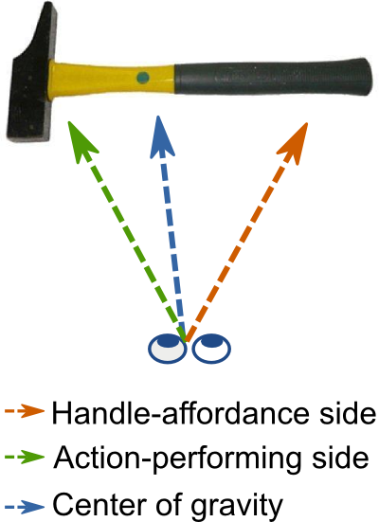
Figure 2: The handle-affordance hypothesis predicts that the eyes will land towards the handle of a graspable object, whereas the action-performing hypothesis predicts that the eyes will go to the other side of the object, that is, in the direction of the action that is implied by the object. The CoG hypothesis predicts that the eyes will land on the object's weighted center.

Current study
Previous studies on the effect of visuomotor priming have yielded equivocal results when it comes to the distribution of visual attention within graspable daily-life objects. Where cueing paradigms demonstrated an attentional shift away from the handle (Roberts & Humphreys, 2006), or no attentional shift at all (Vainio et al., 2007), Myachykov and colleagues (2013) found a bias towards the handle. Importantly, to our knowledge, none of these studies have taken the low-level properties (notably, the CoG) of the stimuli into account. This is crucial, because if the eyes are indeed drawn towards the CoG of a visual display (e.g. Findlay, 1982; Vitu, 2008; Zelinsky et al., 1997), the attentional shift towards the action-performing side observed by Roberts & Humphreys (2006) may simply be explained by the fact that, on average, their stimuli contained more pixels on this side; or vice versa for the bias towards the handle side observed by Myachykov and colleagues (2013).
The purpose of the current study was to investigate the contribution and time course of low-level CoG versus high-level object-affordance effects on where the eyes land on isolated daily-life objects. To this end, we recorded eye movements of participants who viewed simple visual displays containing one isolated graspable object. The object was initially presented in peripheral vision, such that participants' initial saccades brought the object into foveal vision. Before giving a response, participants typically also made one or more refixations within the boundaries of the object. We analyzed the landing positions of both the initial saccades and the refixations, in order to examine whether they were biased to the object's handle, the object's action-performing side, or the object's CoG. It is of note that the three hypotheses are not mutually exclusive, because their effects may come into play with different time courses. More precisely, we predicted that saccades that are executed early in time would be more subject to CoG effects (Coëffé & O’Regan, 1987; Vitu et al., 2006), whereas saccades that are executed later in time would be more subject to object-based, higher level effects.

Experiment 1

Methods
Stimuli and data are available from the first author's website: http://www.cogsci.nl/lvanderlinden/

Participants
Eighteen observers participated in Experiment 1. All were right-handed, had normal or corrected-to-normal vision, and were naive as to the purpose of the experiment. They received payment (€10 per hour) in return for their participation and gave their written informed consent.

Apparatus
Participants sat in front of a computer screen in a dimly-lit room. Stimulus presentation was controlled by OpenSesame (Mathôt, Schreij, & Theeuwes, 2012) in combination with PsychoPy (Peirce, 2007) on a 21'' CRT monitor with a resolution of 1024 by 768 px and a refresh rate of 100 Hz. The distance between the participant's eyes and the monitor was 75 cm and was kept constant by stabilizing the participant's head with a chin rest. Manual responses were collected on a button box. Eye-position data of the right eye were recorded with a remote EyeLink 1000 system (SR Research Ltd., Mississauga, Ontario, Canada) with a sampling rate of 1000 Hz. Viewing was binocular.

Materials
We selected 18 colored photographs of daily-life objects from two standardized stimulus sets (Brodeur, Dionne-Dostie, Montreuil, Lepage, & Op de Beeck, 2010; Moreno-Martínez & Montoro, 2012). Half of the objects were kitchen utensils, whereas the other half were garage tools. All objects were relatively long and narrow (width: 4.4°-5.7°; height: 0.65°-2.02°), and were oriented horizontally. Per category, seven of the nine objects were 'handled', i.e. more graspable on one side than the other (e.g. a knife). The remaining four objects (two from each category) were roughly symmetrical, and equally graspable on both sides (e.g. a ruler). These were used as fillers, to decrease the chance that participants would notice our handle-orientation manipulation (explained below). The filler trials were not included in the analyses.

Design
Objects were presented in two different orientations, such that their handle was pointing either towards the left or towards the right. This enabled us to control for any potential overall bias towards one side of the screen. We crossed this manipulation with a contrast manipulation (contrast degraded at the left or the right side of the object, or no contrast manipulation), resulting in a 2x3 within-subjects factorial design. Because the sole purpose of the contrast manipulation was to perform a sanity check on our CoG calculation (explained below), the methods and results of the contrast-degraded trials are not included in the main text (but see Appendix 3).
To investigate the time course of low-level versus high-level effects on saccadic landing positions, a wide range of saccade latencies was needed. To this aim, we used both 'step' (or '0-ms gap' and 'overlap' trials, since the latter are known to result in longer saccade latencies than the former (Saslow, 1967). Thus, on half of the fixation dot was removed as soon as the object appeared on screen ('step' trials). On the other half of the trials the fixation dot remained on screen during object presentation ('overlap' trials). Objects were presented either in the upper or in the lower visual field at an eccentricity randomly varying between 5° and 7°.

Procedure
The experiment started with a nine-point grid calibration procedure. A typical trial sequence is shown in Figure 2a. Before the start of each trial, a central one-point eye-tracker recalibration ('drift correction') was performed. The trial proper started with a central black fixation dot (diameter: 0.24°) on a white background. After a random interval (μ = 400 ms, σ = 50 ms, from a Gaussian, min. = 200 ms, max. = 1000 ms), and only when a stable fixation was detected within a 1.5° vertical region centered on the fixation dot, the object appeared in the upper or lower visual field, while the fixation dot either disappeared or stayed on screen (see above). The vertical eccentricity of the stimulus was random (min. = 5°, max. = 7°, M = 6.19°, SD = 0.62°). The object's center (i.e. the middle of the bitmap) was aligned with the vertical meridian (see Figure 2b).
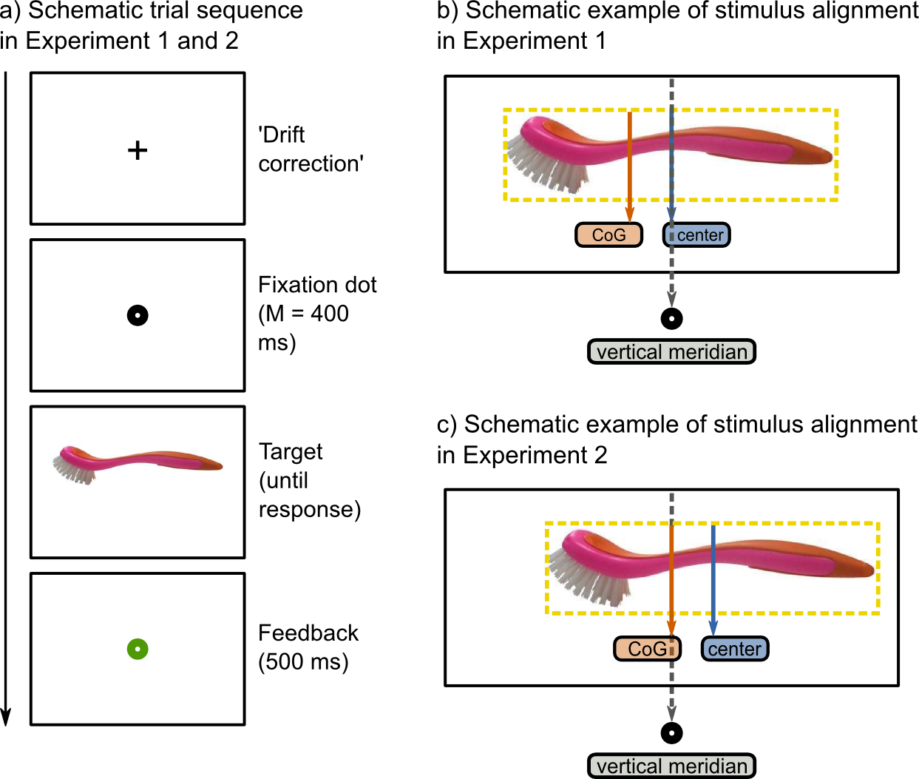
Figure 2: a) Schematic trial sequence of Experiment 1 and 2. b) In Experiment 1, the object's absolute center was aligned with the vertical meridian. c) In Experiment 2, the object's CoG was aligned with the vertical meridian. (The CoG of the washing brush is exaggerated for the sake of visualization.)
Participants were instructed to move their eyes towards the object as quickly and accurately as possible. Next, they had to categorize it as either a kitchen utensil or a garage tool by pressing a right- or left-hand button. A button press was effective only when participants gazed at the object (i.e. when fixation position did not deviate more than 1.5° from the vertical center of the object for 50 consecutive samples). If this fixation check took more than 1000 ms to complete, the check was considered as failed. In this case, participants heard a brief warning beep. Trials on which this happened, were not analyzed. The object remained on screen until a response was made or a timeout of 2500 ms occurred. Finally, a central red (for incorrect) or a green (for correct) fixation dot was displayed (500 ms) to inform participants about the correctness of their response.
The experiment contained 6 blocks of 96 trials, and started with 6 practice trials. Within blocks, objects were presented once in every condition, resulting in six object repetitions per block. Trial orders per block were determined according to a Latin-square design, such that potential object-repetition effects would not be confounded with the manipulations of interest.. The response rule (e.g. left for kitchen, right for garage) was swapped half-way through the experiment, and the order of response rules was counterbalanced across participants. At the end of every block, participants were informed about their average response time and accuracy on the categorization task. If their accuracy was below 85 percent correct, they received a warning message asking them to be more accurate.

Data analysis
Given our horizontal manipulation of handle orientation, only the x-coordinates of saccadic landing positions are reported here. More precisely, we normalized these coordinates such that, irrespective of Handle Orientation (left or right) and the object's exact size, landing positions ranged between -.5 and .5. Thus, a value of .5 meant that the eyes landed at the extreme border of the object's handle side, whereas a value of -.5 indicated that the eyes landed at the extreme border of the object's action-performing side. A value of 0 indicated that the eyes landed exactly at the middle of the bitmap.
To calculate the object's CoG, we applied an edge-detection algorithm and subsequently determined the object's weighted center (see Appendix 1). This calculation revealed that, on average, the CoG of our stimuli was shifted (by about 1.25 % of the object's width) towards the action-performing side. For only 3 out of 14 objects, the CoG was shifted towards the handle side. We emphasize that we do not consider this a confound or a disadvantage of our design. After all, one of our purposes was to investigate whether such (asymmetries in) low-level stimulus properties (which most likely also hold for other stimulus sets of graspable objects) provide an alternative explanation for previously-reported handle-affordance or action-performing effects.
Saccades were detected using the built-in EyeLink saccade/fixation-detection algorithm with the default parameters. We found that participants executed at least one (100%) or two (70%) saccades before making a manual response. The first saccade brought the peripherally-presented object into foveal vision, whereas the second saccade was made within the borders of the already foveated object. These landing positions were compared to two different reference points: the object's absolute center (i.e., the middle of the bitmap, which was aligned with the vertical meridian); and the object's CoG. This resulted in four dependent variables: the landing positions of initial saccades and refixations relative to the absolute center; and relative to the CoG, of the objects. We conducted linear mixed-effects (LME) analyses for each of these dependent variables separately.
To investigate the influence of object orientation, we examined whether landing positions significantly differed from their reference point in the direction of, or away from the handled side of the object. Handle Orientation was not included as a factor in the LME, because the effect of this manipulation was already captured by the fact that we normalized landing positions (such that positive values indicate landing positions towards the handle, and negative values indicate landing positions towards the action-performing part). Thus, a main effect of Handle Orientation would be evident when landing positions are significantly different from their reference point (absolute center or CoG). To examine the time course of any potential gaze bias, we used the range of saccade latencies, that resulted from our gap versus overlap manipulation and from natural intra-individual variability, by entering Saccade Latency (determined relative to stimulus onset) as a fixed effect.
For the sake of completeness we also included Response Hand (left or right) and Target Eccentricity (continuous between ± 5 and ±7) as fixed effects. We did not include Gap Condition ('step' or 'overlap'), because this manipulation was used to influence saccade latencies, which we did include as a fixed effect. Participant and Object were entered as random effects. Markov chain Monte Carlo (MCMC) simulations were used to estimate p values and 95% confidence intervals (Baayen, Davidson, & Bates, 2008).
In all Figures, fitted functions (plotted in dotted lines) represent gaze bias over time. Shaded areas around these lines indicate 95% confidence intervals, which were determined on the basis of the function's intercept. Thus, no overlap with the reference point (gray horizontal line) indicates that a gaze bias is significantly different from zero (p < .05). The slope of the relationship between latencies and landing positions indicates whether the direction or the strength of the bias changed over time.
Trials were excluded according to the following criteria: No saccade was detected (0.04%), the manual response was incorrect (5.43%), the initial saccade did not cross an imaginary line between the vertical center of the display and the smallest-possible target eccentricity (0.24%), an anticipatory saccade was made before stimulus onset (0.08%) or our gaze-contingent fixation checks (see Procedure) failed (15.86%). Finally, we discarded trials on which landing positions or saccade latencies deviated more than 2.5 SD from the participants' mean (initial saccades: relative to absolute center: 3.03%, relative to CoG: 3.60%, refixations: relative to absolute center: 5.37%, relative to CoG: 5.44%).

Results
We found that initial saccades showed a bias relative to both reference points. However, strikingly, they did so in opposite manners. Relative to the object's absolute center, initial saccades showed an average bias towards the action-performing side (M = -0.039, SE = 0.004). In contrast, relative to the object's CoG, initial saccades showed an average bias towards the handle side (M = 0.021, SE.= 0.004). As can be seen from Figure 3, the effect of reference point on initial landing positions was particularly strong when saccade latency was short. For longer latencies, the eyes showed an average deviation towards the object's action-performing side irrespective of reference point. In line with this observation, our LME analyses revealed that initial landing positions correlated negatively with saccade latency. (see Table 1) This indicates that the longer the latency of an initial saccade, the stronger its bias towards the object's action-performing side.
Furthermore, we found that refixations were directed towards the object's action-performing side throughout the entire range of refixation latencies, irrespective of reference point (relative to absolute center: M = -0.196, SE = 0.012; relative to CoG: M = -0.129, SE = 0.010, see Figure 3). This is consistent with the observation that long-latency initial saccades showed a similar bias. Nevertheless, it is important to note that the time that elapsed since stimulus onset cannot entirely account for participants' landing positions: For initial saccades and refixations that were initiated with comparable latencies (i.e. around 250 ms after stimulus onset), the bias was stronger for refixations than for initial saccades (i.e. the curves of the refixations laid below the curves of the initial saccades, thus indicating that the eyes landed further away from the reference point). None of the other effects were significant (see Table 1).
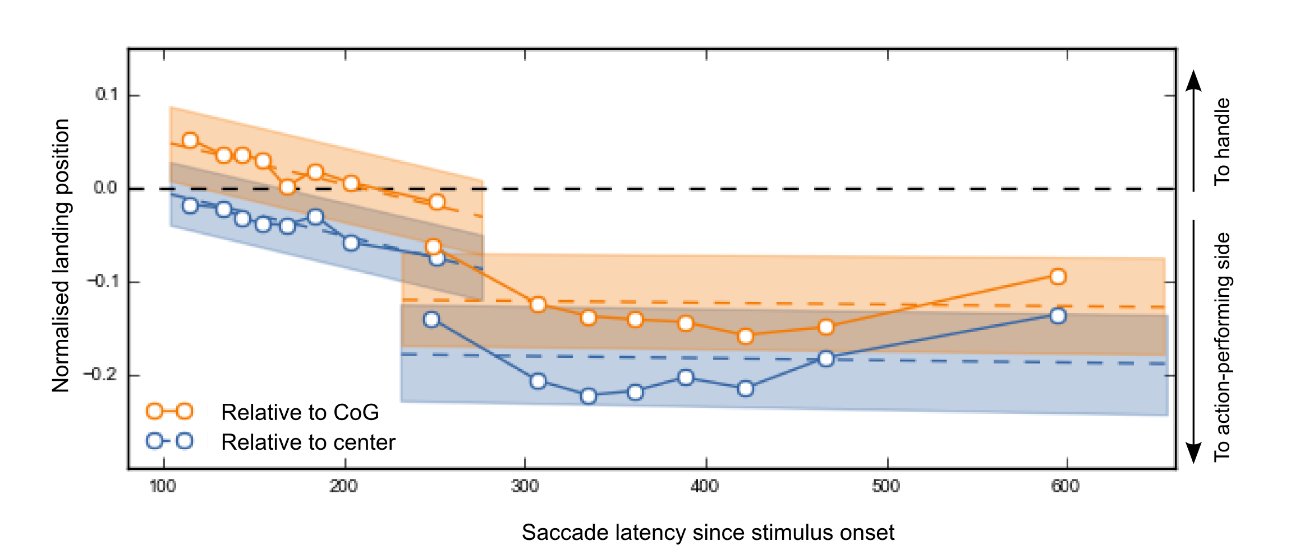
Figure 3: Average gaze bias of initial saccades (left) and refixations (right), relative to the object's absolute center (orange), and relative to the object's CoG (blue), as a function of time relative to stimulus onset. The y-axis depicts normalized landing positions, such that the gray dotted line indicates landing positions on the reference point (i.e., absolute center or CoG), positive values indicate landing positions on the objects' handle side, and negative values indicate landing positions on the objects' action-performing side (see arrows on the right y-axis). Markers indicate saccade-latency bin means, and are plotted for visualization purposes only. Orange and blue dotted lines indicate linear regressions yielded by the four LME analyses, and shaded areas indicate 95% confidence intervals based on their respective intercepts. Consequently, no overlap with the reference point (gray horizontal line) indicates that gaze bias is significantly different from zero (p < .05). The slope of the relationship between latencies and landing positions indicates whether the direction or the strength of the bias changed over time.
Effect | Slope | SE | Low 95% CI | Up 95% CI | t | p
 | Landing positions initial saccades relative to object's center
Saccade latency | -0.0004 | 0.0001 | -0.0004 | -0.0003 | 8.3227 | < .00001*
Response hand (Right) | 0.0044 | 0.0043 | 0.0044 | 0.0125 | 1.0117 | .3118
Eccentricity | 0.0000 | 0.0000 | 0.0000 | 0.000 | 1.8294 | .0675
 | Landing positions initial saccades relative to the object's CoG
Saccade latency | -0.0004 | 0.0001 | -0.0006 | -0.0003 | 8.1599 | <.00001*
Response hand (Right) | 0.0045 | 0.0043 | -0.0041 | 0.0129 | 1.0395 | .26968
Eccentricity | 0.0000 | 0.000 | 0.0000 | 0.0000 | 1.5473 | .1247
 | Landing positions refixations relative to the object's absolute center
Saccade latency | 0.0000 | 0.0000 | -0.0001 | 0.0001 | 0.489 | .6249
Response hand (Right) | 0.0018 | 0.0066 | -0.0113 | 0.0149 | 0.2781 | .7810
Eccentricity | 0.000 | 0.000 | 0.0000 | 0.0000 | 0.7778 | .4368
 | Landing positions refixations relative to the object's CoG
Saccade latency | 0.0000 | 0.000 | -0.0001 | 0.0001 | 0.4052 | .6854
Response hand (Right) | 0.0037 | 0.0067 | -0.0098 | 0.0163 | 0.5611 | .5748
Eccentricity | 0.000 | 0.000 | 0.000 | 0.000 | 0.2813 | .7785
Table 1: Results for the fixed effects in the LME analyses for the four dependent variables. Significant effects are indicated by an asterisk.

Finally, we investigated whether landing positions were unimodally distributed. To this end, we plotted landing-position distributions separately for three saccade-latency intervals (fastest, intermediate, and slow). First, we removed the between-subjects variability from saccade latencies (Cousineau, 2005). Next, we divided the resulting normalized saccade latencies into three equal bins. Then, per saccade-latency bin, we divided landing positions into 15 equal landing-position bins. Figure 4 shows that the distributions of initial saccades appear to be unimodal. They peak just to the left (i.e. in the action-direction) of the absolute center (see Figure 4a), and just to the right (i.e., in the handle direction) of the CoG (see Figure 4c). The distributions of refixations show a main peak towards the action-performing part of the object, and a second peak or tail slightly towards the handle side of the object. The latter may explain the pattern of the latest-triggerred refixations shown in Figure 3, and suggests that initial saccades that were launched very late in time, showed a tendency towards bimodality (rather than that they were 'rebiased' towards the reference point, as the slight u-curve in Figure 3 may suggest).
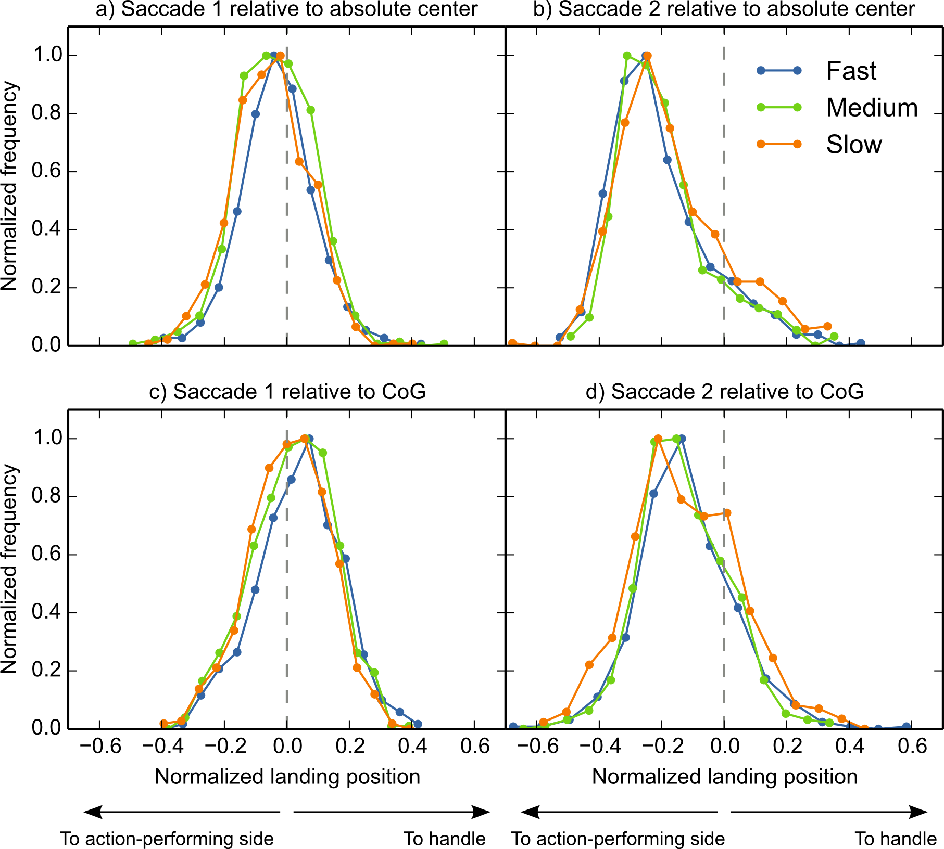
Figure 4: Distributions of initial saccades (left) and refixations (right) relative to the object's absolute center (upper) and relative to the object's CoG (lower). Given the influence of saccade latency on landing positions, we plotted separate distributions for the 33% fastest (blue), medium (green), and slowest (orange) saccades. The x-axis depicts normalized landing positions, such that the gray dotted line indicates landing positions on the reference point (i.e., absolute center or CoG), positive values indicate landing positions on the objects' handle side, and negative values indicate landing positions on the objects' action-performing side. In order to keep the range on the y-axis constant, we normalized absolute frequencies relative to their minimum and maximum frequency within a given distribution.

Discussion
Experiment 1 revealed that, on average, initial saccades did not land exactly at the object's absolute center, nor exactly at its CoG. Instead, the eyes landed somewhere in between, especially when saccade latencies were short. The fact that the direction of gaze bias reversed depending on the reference point argues against a high-level, object-based effect. Rather, we considered the following: Possibly, when saccade latency was low, the eyes were drawn towards the CoG. However, on top of that, the eyes may have shown a tendency to land close to the vertical meridian. Regardless of the mechanism underlying this additional vertical-meridian bias (e.g. a task strategy, cf. Pajak & Nuthmann, 2013; or a bias to remain to the center of the display, cf. Tatler, 2007) the net result would be the pattern of results observed here. This line of reasoning is schematically depicted in Figure 5. We examined this possibility in Experiment 2.

Furthermore, in line with the action-performing hypothesis (Roberts & Humphreys, 2006), Experiment 1 revealed that when initial saccades were launched with longer latencies, or when a refixation was generated, the eyes were systematically directed towards the object's action-performing side.

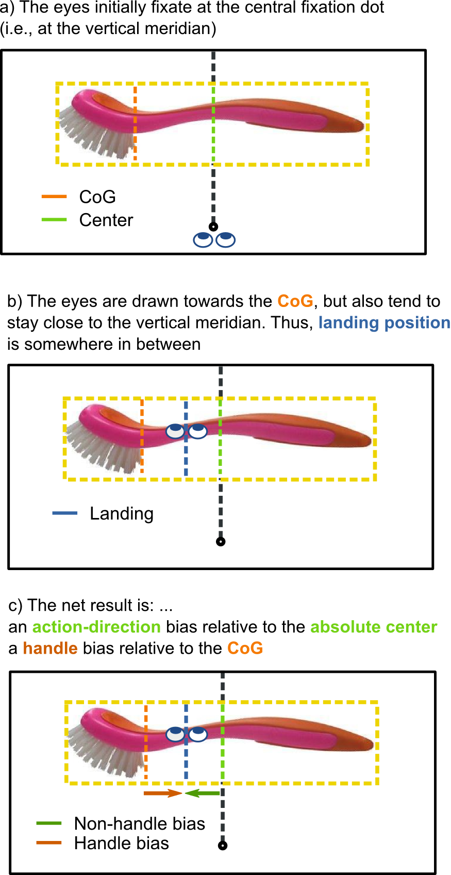

Figure 5: Schematic representation of how a CoG effect, combined with a tendency of the eyes to stay close to the vertical meridian, may result in a bias towards the object's action-performing versus the object's handle side, depending on the reference point (i.e. the object's absolute center or its CoG, respectively). (The CoG of the washing brush is exaggerated for the sake of visualization.)

Experiment 2
Experiment 2 further investigated the landing positions of saccades towards and within isolated graspable objects. It differed in a small but important manner from Experiment 1: The objects were displayed such that their CoG (instead of their absolute center) was aligned with the vertical meridian (see Figure 2c). The reasoning behind this was as follows. Experiment 1 revealed that the landing positions of initial saccades significantly deviated from both reference points (i.e., the absolute center and the CoG). If this deviation was caused by a tendency to keep the eyes close to the vertical meridian (as proposed in Figure 5), in Experiment 2 the eyes should land approximately at the CoG, and hence the vertical meridian, irrespective of object orientation. In contrast, if the previously-observed early initial deviations did reflect a higher-level, object-based effect, Experiment 2 should reveal a similar bias. In addition, Experiment 2 tested whether we could replicate the action-performing bias in longer-latency initial saccades and refixations.

Methods
Experiment 2 differed from Experiment 1 only on the following aspects. Eighteen different observers participated. Data from one participant were excluded from the analyses because he reported to be left-handed after having participated. Furthermore, we aligned the CoG (instead of the absolute center) of the objects with the vertical meridian (see Figure 3c). Finally, in Experiment 1 the criteria for the gaze-contingent fixation checks (on the fixation dot, before the object was presented, and on the object, before a response could be collected, see Procedure Experiment 1) were set conservatively. This had led to the exclusion of a large number of trials. Therefore, in Experiment 2 we decided not to use any other on-line fixation checks than the one-point eye-tracker recalibration at the beginning of the trial.
As in Experiment 1, participants executed at least one (100%) or two (64%) saccades before categorizing the objects with a button press. The analyses were the same as in Experiment 1, except that we only analyzed the landing positions of these two saccades relative to the CoG, which coincided with the vertical meridian.
Trials were discarded on the basis of the following criteria: The EyeLink saccade-detection algorithm detected no saccades (2.76%), the initial saccade did not cross an imaginary line between the center and the smallest-possible target eccentricity (0.35%), an anticipatory saccade before stimulus onset was made (0.30%), or an erroneous response was given or a timeout occurred (6.26%). Finally, trials on which landing position or saccade latencies deviated more than 2.5 SD from the participants' mean were discarded (first saccade: 3.93%, second saccade: 4.90%)

Results
We found that initial saccades landed approximately on the CoG of the objects (M = -0.005, SE = 0.003). As can be seen from Figure 6, the CoG tendency was especially pronounced for saccades with short latencies (less than about 200 ms), whereas longer-latency saccades deviated towards the action-performing side. Indeed, our LME analysis revealed an inverse relationship between latencies and landing positions of initial saccades (see Table 2), indicating that the later a saccade was executed, the weaker the CoG tendency, in favour of a bias towards the action-performing side.
Furthermore, refixations were biased towards the action-performing side of the objects (M = -0.176, SE = 0.012) throughout the entire distribution of refixation latencies (see Figure 6). However, as in Experiment 1, the time that elapsed since stimulus onset was not sufficient to explain the strength of the action-performing bias, because the latest initial saccades and the earliest refixations almost overlapped in latencies (see x-axis), but not in gaze bias (see gap on the y-axis). None of the other effects were significant (see Table 1).
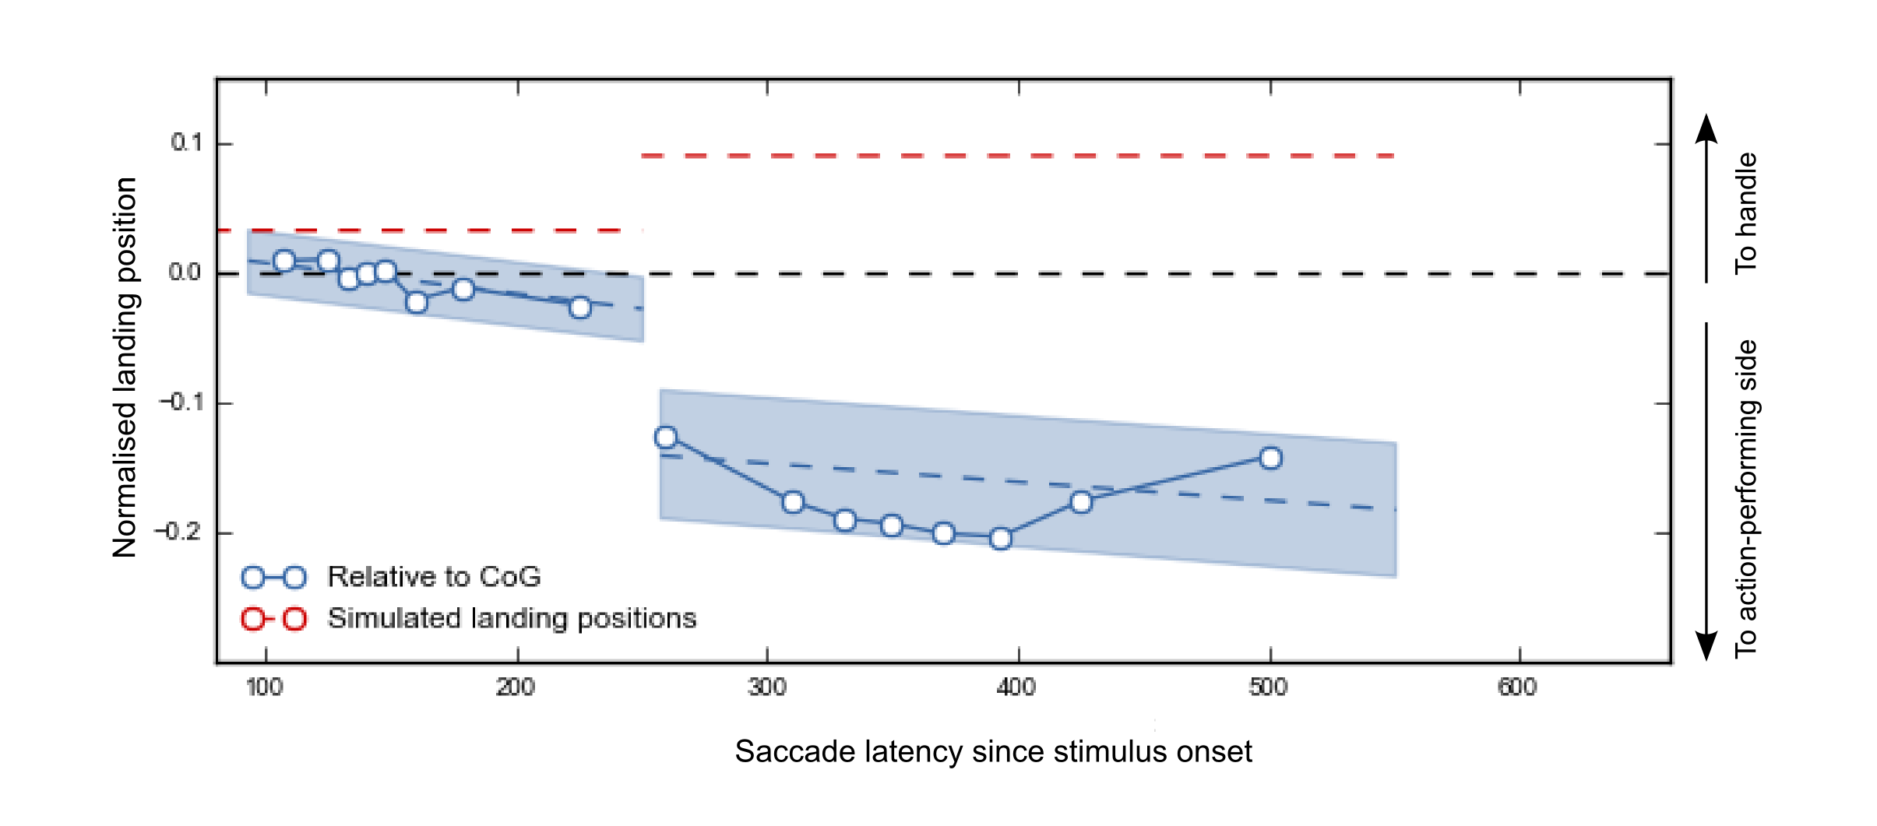
Figure 6: Average gaze bias of initial saccades (left) and refixations (right), relative to the object's CoG (which coincided with the vertical meridian) as a function of time relative to stimulus onset (see caption Figure 3 on how to interpret the Figure). Red-dotted horizontal lines indicate the landing positions of two simulated, saliency-driven saccades. These were simulated on the basis of saliency maps that were generated for the displays used in Experiment 2 (see 'Saliency Simulation').
Effect | Slope | SE | Low 95% CI | Up 95% CI | t | p
 | Landing positions initial saccades relative to object's CoG
Saccade latency | -0.0002 | 0.0001 | -0.0003 | -0.0001 | 4.3077 | <.00001
Response hand (Right) | -0.0014 | 0.0041 | -0.0094 | 0.0065 | 0.3464 | .7291
Eccentricity | 0.000 | 0.000 | 0.0000 | 0.0000 | 0.8589 | .3905
 | Landing positions refixations relative to the object's CoG
Saccade latency | -0.0001 | 0.0001 | -0.0003 | -0.0001 | 2.8869 | .0040
Response hand (Right) | 0.0127 | 0.0067 | -0.0006 | 0.0259 | 1.8811 | .0602
Eccentricity | 0.000 | 0.000 | -0.0001 | 0.0000 | 1.3411 | .1801
Table A1: Results for the fixed effects in the LME analyses for the two dependent variables. Significant effects are indicated by an asterisk.
Finally, as can be seen from Figure 7, landing-position distribution of Fast and Medium initial saccades peaked towards the object's CoG, whereas the distribution of Slow initial saccades was slightly biased towards the action-performing side. Landing-position distributions of refixation saccades peaked more radically towards the action-related side of the objects, and showed a small tail towards the handle, though not as pronounced as in Experiment 1.
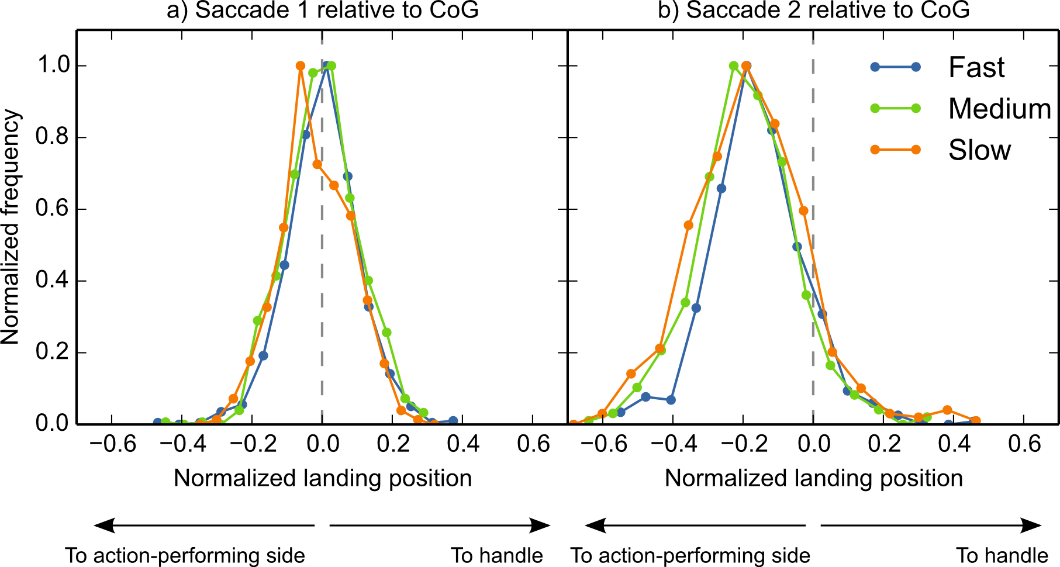
Figure 7: Distributions of landing positions of initial saccades (left) and refixations (right) in Experiment 2, relative to the object's CoG (gray dotted vertical lines, see caption Figure 4 on how to interpret the Figure).

Saliency Simulation
Experiment 1 and Experiment 2 consistently revealed that the bias towards the action-performing side increased with saccade latency, and that it was maximal for refixations. This time course suggests that the action-performing bias takes time to build up, and is the result of higher-level, object-based processing. However, an alternative, low-level explanation cannot yet been ruled out. On average, the action-performing side of our stimuli may have been more salient than the handle side. Hence, even saccades launched with longer latencies may have simply been saliency driven. To test this alternative explanation, we used Itti and colleagues' (1998, see Appendix 2) saliency model to simulate two saccades towards every display used in Experiment 2. These simulated saccades are a best effort to predict where the eyes would land if eye-movement guidance were purely determined by bottom-up visual saliency. The crucial question was whether the simulated saccades would show a similar pattern as the refixations observed in Experiment 2. As can be seen from Figure 6 (red dotted lines), this was not the case. Whereas participants tended to refixate the object's action-performing side, simulated refixations did not show this bias. If anything, they showed a deviation towards the other side of the object. This discrepancy strongly suggests that participants' refixations, and long-latency initial saccades, were not driven by saliency.

Discussion
Experiment 2 revealed that early initial saccades were directed towards the object's CoG, whereas later initial saccades, as well as refixations, were directed towards the object's action-performing part. The early CoG tendency is not due to bimodal landing-position distributions, and the later action-performing bias is not merely a low-level saliency effect. Thus, the latter likely reflects a high-level object-based effect.

General Discussion
The current study investigated to what extent low-level versus high-level effects determine where the eyes land on isolated daily-life objects. We operationalized low-level effects as saccadic averaging towards the object's center-of-gravity (CoG), and high-level effects as visuomotor priming by object affordances. We found that early initial saccades were determined by the object's low-level features, i.e., they landed on the object's CoG. When saccade latency increased, and when a refixation was made, we observed a systematic bias towards the action-performing side of the object.

A Low-Level Center-of-Gravity Effect
In visual displays containing two simple shapes, saccades typically reveal a global effect, such that they land on a location in between the two stimuli (Coren & Hoenig, 1972; Findlay, 1982; for reviews see Van der Stigchel & Nijboer, 2011; Vitu, 2008). This effect is interpreted as a tendency of the eyes to land on the (CoG) of the peripheral configuration, and its neural basis is assumed to be saccadic averaging in the superior colliculus (Findlay & Walker, 1999; Van Opstal & Van Gisbergen, 1989). As suggested by Vitu (2008), saccadic averaging may be the default saccade-programming mode, which is at work irrespective of the task and visual material, and which can only be overcome if saccadic programming time is sufficiently long. Here, we show for the first time that presenting participants with photographs of daily-life objects also yields a global effect. More precisely, we found that participants' early initial saccades landed at the CoG of peripherally presented objects. This finding is an important complement to the above-mentioned literature, and is consistent with the hypothesis that saccadic averaging is a universal phenomenon that occurs independent of stimulus type or task requirements, although it can be overcome when saccade latency is the viewing time of the object is prolonged.
As mentioned in the Introduction, we are not the first to investigate initial landing positions on isolated daily-life objects. For example, Henderson (1993), and Foulsham and Underwood (2009) found that initial on-object landing positions were distributed around the object's center (for similar findings on objects embedded in natural scenes, see Foulsham & Kingstone, 2013; Nuthmann & Henderson, 2010). However, in these studies the CoG of the stimuli was not taken into account. Therefore, it remains unclear whether participants aimed for the object's center per se (as a top-down strategy, cf. McConkie et al., 1988; He & Kowler, 1989), or whether their eyes were simply pulled towards the object's CoG. Although, as aforementioned, these two possibilities are difficult to dissociate due to a lack of specific predictions for the strategic account, our results are in line with the latter, because we found that initial saccades landed at the object's CoG (Experiment 2) rather than at its absolute center (Experiment 1).

High-Level Object-Affordance Effects
Several studies suggested that visuomotor priming biases visuospatial attention. Intriguingly, however, they were equivocal with regard to the direction of this bias. Whereas Myachykov and colleagues (2013) found that the eyes were automatically drawn towards an object's graspable part (i.e. the handle of a teapot), Roberts and Humphreys (2006) found an attentional shift in the direction of the action that is implied by the object (i.e. towards the pouring part of a teapot). The current results tip the balance in favor of the action-performing hypothesis. We found that when time since stimulus onset elapsed, and most particularly when a refixation was executed, participants' eyes were biased towards the object's action-performing side. Importantly, this bias could not be explained by the object's low-level features, because a saliency-model simulation (Itti et al., 1998) revealed that simulated, purely saliency-driven saccades landed elsewhere. Although this gaze bias is in line with the action-performing hypothesis, we note that it might also reflect a tendency to move the eyes towards the part of the object that is most informative for object identification. Indeed, many objects have similar handles, but they differ from one another in their action-performing part. Future studies that simultaneously manipulate both action direction and semantic informativeness could help disentangle the contribution of both processes to eye guidance.
We found that the action-performing bias takes time to build up. Whereas CoG effects intervene early, the action-performing bias of initial saccades increased over time. Refixations showed the same bias to an even larger extent. This finding is consistent with previous studies showing that the contribution of low-level, default mechanisms (Coëffé & O’Regan, 1987; Vitu et al., 2006) dissipates over time, thereby making room for higher-level effects to influence eye guidance (De Graef, Christiaens, & d’ Ydewalle, 1990; Henderson et al., 1999; Parkhurst, Law, & Niebur, 2002; Van Zoest, Donk, & Theeuwes, 2004, but see also Loftus & Mackworth, 1978). Nevertheless, these separate time courses do not explain all variance between initial saccades and subsequent refixations, because the very latest initial saccades still showed a much smaller action-performing bias than the very earliest refixations. The remaining difference could possibly be explained by the fact that initial saccades were made towards a peripherally presented stimulus (in order to foveate it), whereas refixations were made within an already-foveated stimulus. Probably, it is easier to determine which part of the object is the optimal saccade-target location, and to guide the eyes accordingly, when the object is already in (para)foveal vision, as compared to when it is still in peripheral vision.
In contrast to what was shown by Myachykov and colleagues (2013), in our study participants did not preferentially look at the object's handle at any point in time. The discrepancy between their and our results is best explained by the different analyses conducted: whereas we focused on saccadic landing positions, Myachykov and colleagues (2013) measured 'proportional dwell time'. This was calculated as the total time the eyes remained on a given area of interest (i.e., the handle versus the 'body' of the object) divided by the size of the area in pixels. Their results showed that participants spent proportionally more time looking at object's handles, as compared to object's bodies. However, we believe that using proportional dwell times as a dependent measure is only sound when the object's low-level properties, such as its CoG, are taken into account. Without doing so, analyses such as the one carried out by Myachykov and colleagues (2013) may lead to the reported pattern even when handles and bodies were actually fixated to the same extent. This is because for handled objects, the bodies typically contain more pixels than the handles (see Methods Experiment 1). Consequently, when participants gazed, for example, 500 ms on an object's body, containing 100 pixels, and another 500 ms on the handle, containing only 10 pixels, proportional dwell time will be longer on the latter than on the former area of interest. Therefore, it remains unclear whether attention was really automatically captured by the objects' handles.
The discrepancy of our current results with some previous findings, emphasize how important it is to take a stimulus' low-level features (e.g. CoG or saliency) into account. For example, in Experiment 1, we found opposite results for early initial landing positions depending on whether or not we corrected for the object's CoG. Applying only one or the other analysis could have resulted in a striking, yet incorrect, conclusion: a bias towards the object's handle (or towards its action-performing side, depending on the chosen reference point) at the earliest possible processing stage. To avoid these situations, we believe that studies using real objects as stimuli should convincingly show that a potential higher-level effect (e.g. an affordance effect) is not likely to be explained by the low-level features of the stimuli. Such care should not only be taken when measuring bottom-up-driven oculomotor behavior, but also when measuring other cognitive processes, such as attentional capture by object affordances.
In the current study, we did take the low-level properties of our stimuli into account. More precisely, we analyzed on-object landing positions relative to the objects' center-of-gravity, and compared participants' saccades with saccades that were simulated on the basis of visual saliency. The results of these controlled analyses suggested an affordance effect on eye-movement behavior in the direction of the action that is implied by the object (Brown & Robertson, 2007). However, these affordance effects, although assumed to occur automatically, took time to build up. Future studies could manipulate a variety of factors, ranging from low level (e.g. saliency or center of gravity) to high level (e.g. affordances, or semantics, in a visual scene). Doing so may help to better understand eye guidance in simple visual displays as well as eye guidance during natural viewing.

Conclusions
We investigated to what extent low-level CoG effects versus high-level object-affordance effects determine where the eyes land on isolated daily-life objects. We found that when the programming time of initial saccades was short, the eyes were drawn towards the CoG of the object. This supports the hypothesis that the global effect (Coren & Hoenig, 1972; Findlay, 1982), as caused by saccadic averaging in the superior colliculus (Findlay & Walker, 1999; Van Opstal & Van Gisbergen, 1989), is a task-independent default mechanism (Vitu, 2008). When saccade latencies increased, the eyes started to deviate from the CoG, and showed a systematic gaze bias towards the object's action-performing part. In line with previous studies (cf. e.g. Henderson et al., 1999; Parkhurst et al., 2002; Van Zoest et al., 2004), we conclude that low-level CoG effects occur early, whereas higher-level, object-related effects take time to build up.

Acknowledgements
L. van der Linden was supported by a grant ('allocation de recherche') from the French Ministry of Research (2012-2015), and S. Mathôt was supported by ERC grant 230313 attributed to Jonathan Grainger. We thank Sarah Moulay and Emmanuel Santune for collecting the data of Experiment 2. The current work was presented at the 2013 European Conference on Eye Movements (ECEM, 2013) in Lund, Sweden.

Appendix 1: Center-of-gravity calculation
To calculate the center of gravity (CoG) of our stimuli we applied an edge-detection algorithm (i.e. Sobel operator) to the original bitmap image. Next, we calculated the weighted average contrast of the Sobel-filtered image. This procedure ensured that parts of the object where local contrast was high, were weighted more heavily than parts of the object where contrast was low. Examples of high-contrast parts are the object's borders (where contrast with the white background is typically high) and 'rough' surfaces within the object, such as the hairs of a tooth brush. Examples of low-contrast parts are smoothed, continues surfaces, such as the blade of a knife.

Appendix 2: Saliency maps
We used the NeuroMorphic vision toolkit developed by Itti, Koch and Niebur (1998) to simulate saliency-driven eye movements for all trial displays with the following command:

ezvision --in=[input image] -T --output-frames=0-4@EVENT --out=png --textlog=[output log] -+
In a nutshell, this algorithm first generates a saliency map for the input image. Next, simulated eye movements are determined based on the peak of local contrast of the saliency map, combined with a simple inhibition-of-return mechanism. The latter avoided that all simulated eye movements were generated towards the same location (i.e. the location where saliency was highest). Instead, once fixated, the just-fixated location got temporarily inhibited, such that subsequent saccades were directed elsewhere (i.e., towards the next-most salient location).

Appendix 3: Contrast Manipulation
Contrast between stimulus and background should have an influence on the outcome of our CoG calculation. We therefore included a contrast manipulation in our design to investigate (1) whether our CoG calculation was sensitive to this manipulation, and (2) whether it influenced participants' eye movements to a similar extent.
To this purpose, we applied a mask gradient, generated in OpenSesame (Mathôt et al., 2012) by using PsyhoPy (Peirce, 2007), to our stimuli. This led to a degradation of the original stimulus at either the left or the right side (see Figure A1). These contrast-degraded trials were not included in the analyses described in the main text. For the analyses described below, only the contrast-degraded conditions were included. Thus, the part of the data that was analyzed in the main text (the no-contrast-manipulation trials) is excluded from the current supplementary analyses.
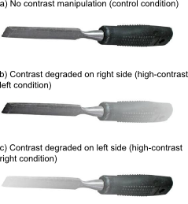
Figure A1: The experimental factor Contrast had three levels: Control (a), High-Contrast Left (b), and High-Contrast Right (c). Only the Control condition was included in the analyses described in the main text. Only the High-Contrast Left and High-Contrast Right conditions were included in the analyses described here.

Contrast Effect on CoG calculation
As expected, the contrast manipulation influenced the CoG calculation. In the control condition (see Figure A1a), on average the CoG was shifted slightly towards the object's action-performing side (1.25% of the object's width, see also main text). If contrast on the action-performing side was preserved (i.e. contrast on the handle side was degraded, see Figure A1b), this bias was slightly stronger (1.56%). On the other hand, if contrast on the handle side was preserved (i.e. contrast on the action-performing side was degraded, see Figure A1c), the average CoG was shifted slightly towards the handle (0.12%).

Contrast Effect on Landing Postions
We investigated the effect of contrast on participants' landing positions. In Experiment 2, objects were presented with their CoG aligned with the vertical meridian. Therefore, we predicted that initial landing positions would not deviate from this reference point, regardless of contrast manipulation (see also main text, Figure 5). For Experiment 1 (where the object's absolute center was aligned with the vertical meridian) the predictions were less clear. Therefore, we only tested the effect of contrast for Experiment 2.
First, we normalized landing positions such that, irrespective of contrast manipulation (left or right side degraded) and the object's exact size, landing positions ranged between -.5 and .5. As a result, positive values indicated a gaze bias towards the high-contrast side, and negative values indicated a gaze bias towards the low-contrast side. A value of 0 would indicate that a saccade was not influenced by our contrast manipulation, but, instead, landed on the object's CoG. Next, we carried out LME analyses for the landing positions of initial saccades and refixations separately. Participant and Object were used as random effects, and Saccade Latency, Handle Orientation (left or right), Response Hand (left or right) and Target Eccentricity ( continuous between ± 5 and ±7) were used as fixed effects. Markov chain Monte Carlo (MCMC) simulation was used to estimate p values and 95% confidence intervals (Baayen et al., 2008). Trials on which saccade latency or landing position deviated more than 2.5 SD's from the participants' means were discarded (initial saccade: 3.24%, refixation: 3.55%).
Our analysis revealed an effect of contrast manipulation on initial landing positions. As can be seen in Figure A2, initial saccades slightly deviated from the CoG in the direction of the object's high-contrast side (M = 0.011, SE = 0.002). This suggests that, after we manipulated the contrast of our stimuli artificially, our CoG calculation slightly underestimated the 'real' CoG. Importantly, however, this underestimation is small, compared with the actual gaze bias observed in the experiments, which shows that our simple edge-detection algorithm is a fairly good approximation of the 'true' CoG. Furthermore, the LME analysis revealed an effect of saccade latency (see Table A1), indicating that when saccade latency increased, the initial deviation towards the object's high-contrast side became weaker. In line with this tendency, refixations were also deviated towards the object's low-contrast side (M = -0.05, SE = 0.004). This pattern is probably best explained as a high-level compensatory effect: Participants directed their gaze towards the part of the object that was less visible, in order to maximize visual-information uptake.
We also found an effect of saccade latency on refixation landing positions, indicating that the bias towards the low-contrast side decreased over time. As can be seen from the distributions in Figure A3, the latter does not mean that later-occurring refixations were 'rebiased' towards the CoG on a trial level. Instead, they were distributed bimodally, indicating that they were either directed towards the high-contrast or the low-contrast side.
Our LME analysis also revealed an effect of response hand on refixation landing positions (see Table A1), indicating that the bias towards the low-contrast side was larger when participants responded with their right hand (M = -0.065, SE = 0.007) as compared to their left hand (M = -0.042, SE = 0.007). Finally, we found an effect of target eccentricity on initial landing positions (see Table A1), indicating that the bias towards the high-contrast side was larger for objects presented in the upper visual field (M = 0.016, SE = 0.003) than for objects presented in the lower visual field (M = 0.007, SE = 0.003).
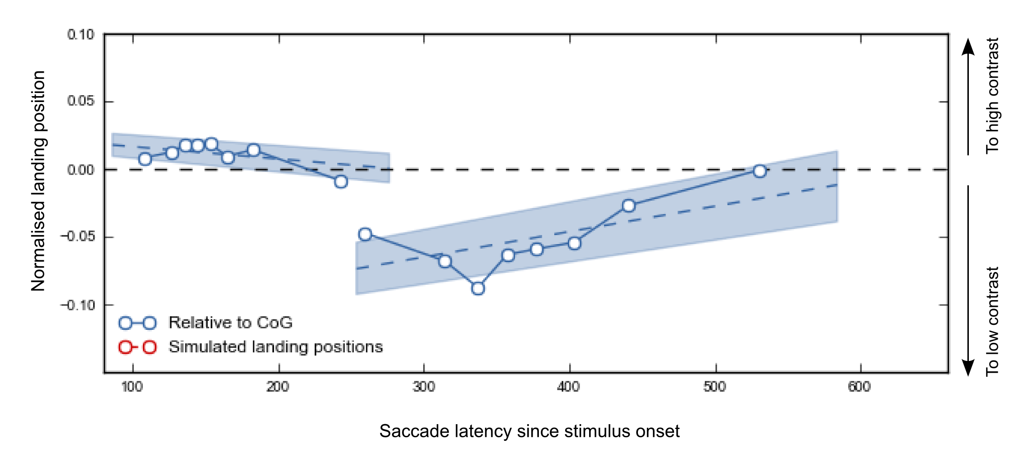
Figure A2: Average gaze bias for initial saccades (left) and refixations (right) in Experiment 2, relative to the object's CoG (which coincided with the vertical meridian) as a function of time relative to stimulus onset. The y-axis depicts normalized landing positions, such that the gray dotted line indicates landing positions on the reference point (i.e., absolute center or CoG), positive values indicate landing positions on the objects' high-contrast side, and negative values indicate landing positions on the objects' low-contrast side (see arrows on the right y-axis). See caption Figure 3, main text, on how to interpret the rest of the Figure..
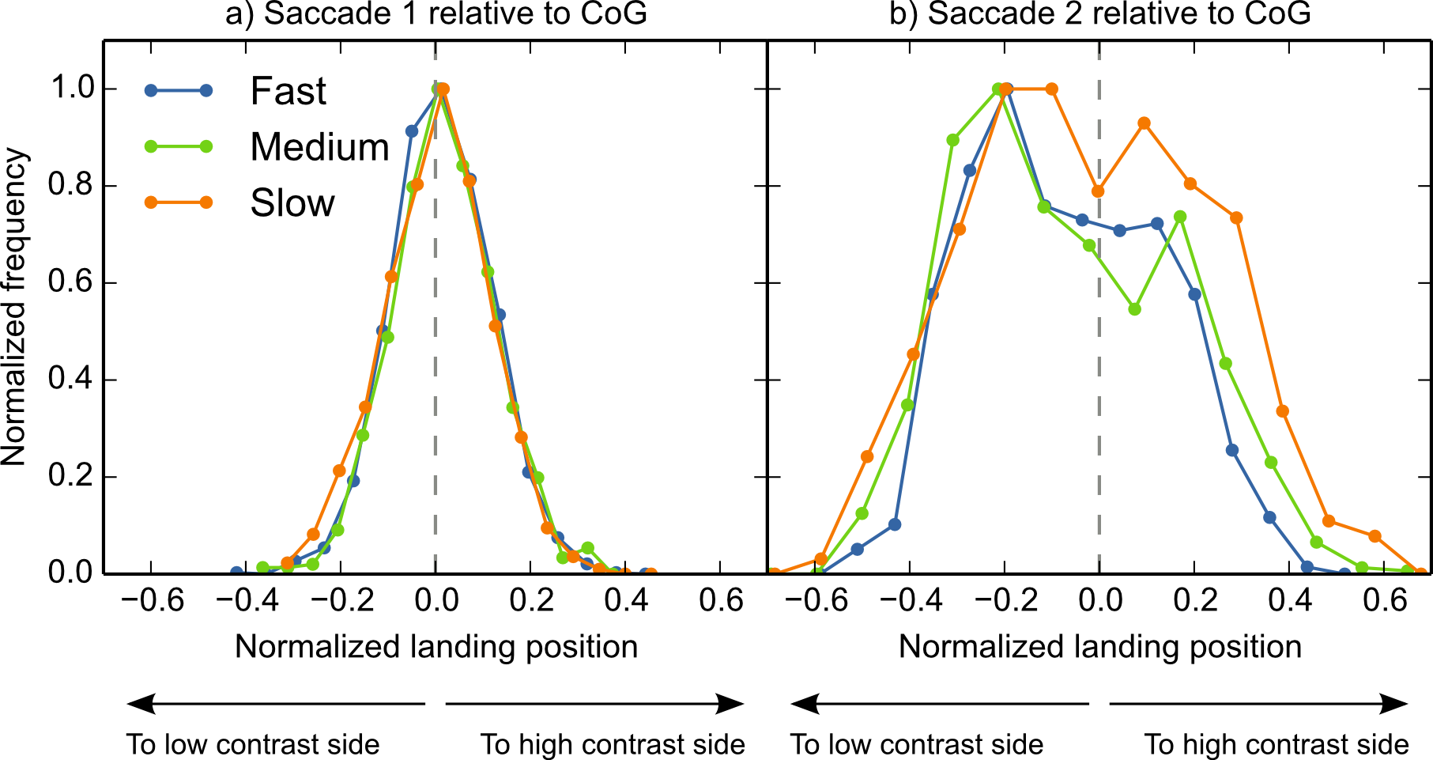
Figure A3: Distributions of landing positions of initial saccades (left) and refixations (right) in Experiment 2, relative to the object's CoG. The x-axis depicts normalized landing positions, such that the gray dotted line indicates landing positions on the reference point (i.e., absolute center or CoG), positive values indicate landing positions on the objects' handle side, and negative values indicate landing positions on the objects' action-performing side. See Figure 4, main text, on how to interpret the rest of the Figure.

Effect | Slope | SE | Low 95% CI | Up 95% CI | t | p
 | Landing positions initial saccades relative to object's CoG
Saccade latency | -0.0001 | 0.000 | -0.0001 | 0.0000 | 2.2417 | .0250*
Response hand (Right) | -0.0016 | 0.0034 | -0.0081 | 0.0051 | 0.4686 | .6393
Handle side (Right) | -0.0019 | 0.0034 | -0.0087 | 0.0046 | 0.5516 | .5814
Eccentricity | 0.000 | 0.000 | 0.0000 | 0.0000 | 2.4999 | .0125*
 | Landing positions refixations relative to the object's CoG
Effect | Estimate | SE | Lower 95% CI | Upper 95% CI | t | p
Saccade latency | 0.0002 | 0.0001 | 0.0001 | 0.0003 | 3.3599 | .0008*
Response hand (Right) | -0.0234 | 0.0089 | -0.0401 | -0.0058 | 2.6358 | .0084*
Handle side (Right) | -0.0092 | 0.0089 | -0.0264 | 0.0090 | 1.0344 | .3010
Eccentricity | 0.000 | 0.0000 | 0.000 | 0.0001 | 0.9803 | .3270
Table A1: Results for the fixed effects obtained by the LME. Significant effects are indicated by an asterisk.

References
Baayen, R. H., Davidson, D. J., & Bates, D. M. (2008). Mixed-effects modeling with crossed random effects for subjects and items. Journal of Memory and Language, 59(4), 390–412.
Bindemann, M., Scheepers, C., & Burton, A. M. (2009). Viewpoint and center of gravity affect eye movements to human faces. Journal of Vision, 9(2), 7. doi:10.1167/9.2.7
Bindemann, M., Scheepers, C., Ferguson, H. J., & Burton, A. M. (2010). Face, body, and center of gravity mediate person detection in natural scenes. Journal of Experimental Psychology: Human Perception and Performance, 36(6), 1477.
Brodeur, M. B., Dionne-Dostie, E., Montreuil, T., Lepage, M., & Op de Beeck, H. P. (2010). The Bank of Standardized Stimuli (BOSS), a new set of 480 normative photos of objects to be used as visual stimuli in cognitive research. PloS ONE, 5(5), e10773.
Brown, R. M., & Robertson, E. M. (2007). Off-line processing: reciprocal interactions between declarative and procedural memories. The Journal of Neuroscience, 27(39), 10468.
Chao, L. L., & Martin, A. (2000). Representation of manipulable man-made objects in the dorsal stream. NeuroImage, 12(4), 478–484.
Clark, V. P., & Hillyard, S. A. (1996). Spatial selective attention affects early extrastriate but not striate components of the visual evoked potential. Journal of Cognitive Neuroscience, 8(5), 387–402.
Coëffé, C., & O’Regan, J. K. (1987). Reducing the influence of non-target stimuli on saccade accuracy: predictability and latency effects. Vision Research, 27(2), 227–240.
Coren, S., & Hoenig, P. (1972). Effect of non-target stimuli upon length of voluntary saccades. Perceptual and Motor Skills, 34(2), 499–508.
Cousineau, D. (2005). Confidence intervals in within-subject designs: A simpler solution to Loftus and Masson’s method. Tutorial in Quantitative Methods for Psychology, 1(1), 42–45.
Craighero, L., Fadiga, L., Umiltà, C., & Rizzolatti, G. (1996). Evidence for visuomotor priming effect. NeuroReport, 8(1), 347.
De Graef, P., Christiaens, D., & d’ Ydewalle, G. (1990). Perceptual effects of scene context on object identification. Psychological Research, 52(4), 317–329.
Deubel, H., Findlay, J., Jacobs, A., & Brogan, D. (1988). Saccadic eye movements to targets defined by structure differences. Eye Movement Research: Physiological and Psychological Aspects, 107–145.
Findlay, J. M. (1982). Global visual processing for saccadic eye movements. Vision Research, 22(8), 1033–1045.
Findlay, J. M., & Brown, V. (2006). Eye scanning of multi-element displays: II. Saccade planning. Vision Research, 46(1), 216–227.
Findlay, J. M., & Walker, R. (1999). How are saccades generated? Behavioral and Brain Sciences, 22(04), 706–713.
Foulsham, T., & Kingstone, A. (2013). Optimal and preferred eye landing positions in objects and scenes. The Quarterly Journal of Experimental Psychology, 66(9), 1707–17288.
Foulsham, T., & Underwood, G. (2009). Does conspicuity enhance distraction? Saliency and eye landing position when searching for objects. The Quarterly Journal of Experimental Psychology, 62(6), 1088–1098.
Gibson, J. J. (1977). The theory of affordances. Perceiving, Acting, and Knowing: Toward an Ecological Psychology, 67–82.
Grèzes, J., Tucker, M., Armony, J. L., Ellis, R., & Passingham, R. E. (2003). Objects automatically potentiate action: an fMRI study of implicit processing. European Journal of Neuroscience, 17(12), 2735–2740.
Handy, T. C., Grafton, S. T., Shroff, N. M., Ketay, S., & Gazzaniga, M. S. (2003). Graspable objects grab attention when the potential for action is recognized. Nature Neuroscience, 6(4), 421–427.
Henderson, J. M. (1993). Eye movement control during visual object processing: Effects of initial fixation position and semantic constraint. Canadian Journal of Experimental Psychology/Revue Canadienne de Psychologie Expérimentale, 47(1), 79.
Henderson, J. M. (2003). Human gaze control during real-world scene perception. Trends in Cognitive Sciences, 7(11), 498–504.
Henderson, J. M., Weeks Jr, P. A., & Hollingworth, A. (1999). The effects of semantic consistency on eye movements during complex scene viewing. Journal of Experimental Psychology: Human Perception and Performance, 25(1), 210.
He, P., & Kowler, E. (1989). The role of location probability in the programming of saccades: Implications for “center-of-gravity” tendencies. Vision Research, 29(9), 1165–1181. doi:10.1016/0042-6989(89)90063-1
He, P., & Kowler, E. (1991). Saccadic localization of eccentric forms. Journal of the Optical Society of America A, 8(2), 440–449. doi:10.1364/JOSAA.8.000440
Itti, L., & Koch, C. (2000). A saliency-based search mechanism for overt and covert shifts of visual attention. Vision Research, 40(10), 1489–1506.
Itti, L., & Koch, C. (2001). Computational modelling of visual attention. Nature Reviews Neuroscience, 2(3), 194–203.
Itti, L., Koch, C., & Niebur, E. (1998). A model of saliency-based visual attention for rapid scene analysis. IEEE Transactions on Pattern Analysis and Machine Intelligence, 20(11), 1254–1259.
Jeannerod, M., Arbib, M. A., Rizzolatti, G., & Sakata, H. (1995). Grasping objects: the cortical mechanisms of visuomotor transformation. Trends in Neurosciences, 18(7), 314–320.
Kaufman, L., & Richards, W. (1969). Spontaneous fixation tendencies for visual forms. Perception & Psychophysics, 5(2), 85–88.
Kowler, E., & Blaser, E. (1995). The accuracy and precision of saccades to small and large targets. Vision Research, 35(12), 1741–1754.
Loftus, G. R., & Mackworth, N. H. (1978). Cognitive determinants of fixation location during picture viewing. Journal of Experimental Psychology: Human Perception and Performance, 4(4), 565.
Mathôt, S., Schreij, D., & Theeuwes, J. (2012). OpenSesame: An open-source, graphical experiment builder for the social sciences. Behavior Research Methods, 1–11.
McConkie, G. W., Kerr, P. W., Reddix, M. D., & Zola, D. (1988). Eye movement control during reading: I. The location of initial eye fixations on words. Vision Research, 28(10), 1107–1118.
Moreno-Martínez, F. J., & Montoro, P. R. (2012). An ecological alternative to Snodgrass & Vanderwart: 360 high quality colour images with norms for seven psycholinguistic variables. PloS ONE, 7(5), e37527.
Myachykov, A., Ellis, R., Cangelosi, A., & Fischer, M. H. (2013). Visual and linguistic cues to graspable objects. Experimental Brain Research, 229(4), 545–599. doi:10.1007/s00221-013-3616-z
Nuthmann, A., & Henderson, J. M. (2010). Object-based attentional selection in scene viewing. Journal of Vision, 10(8), 1–19.
O’Regan, J. K., Lévy-Schoen, A., Pynte, J., & Brugaillère, B. (1984). Convenient fixation location within isolated words of different length and structure. Journal of Experimental Psychology: Human Perception and Performance, 10(2), 250.
Ottes, F. P., Van Gisbergen, J. A., & Eggermont, J. J. (1985). Latency dependence of colour-based target vs nontarget discrimination by the saccadic system. Vision Research, 25(6), 849–862.
Pajak, M., & Nuthmann, A. (2013). Object-based saccadic selection during scene perception: Evidence from viewing position effects. Journal of Vision, 13(5), 1–21. doi:10.1167/13.5.2
Parkhurst, D., Law, K., & Niebur, E. (2002). Modeling the role of salience in the allocation of overt visual attention. Vision Research, 42(1), 107–123.
Peirce, J. W. (2007). PsychoPy—psychophysics software in Python. Journal of Neuroscience Methods, 162(1), 8–13.
Posner, M. I., Snyder, C. R., & Davidson, B. J. (1980). Attention and the detection of signals. Journal of Experimental Psychology: General, 109(2), 160–174.
Rayner, K. (1979). Eye guidance in reading: Fixation locations within words. Perception, 8(1), 21–30.
Rayner, K. (1998). Eye movements in reading and information processing: 20 years of research. Psychological Bulletin, 124(3), 372.
Rayner, K., Liversedge, S. P., Nuthmann, A., Kliegl, R., & Underwood, G. (2009). Rayner’s 1979 paper. Perception, 38(6), 895.
Richards, W., & Kaufman, L. (1969). “Center-of-gravity” tendencies for fixations and flow patterns. Perception & Psychophysics, 5(2), 81–84.
Roberts, K. L., & Humphreys, G. W. (2006). Action-related objects influence the distribution of visuospatial attention. Quarterly Journal of Experimental Psychology, 64(4), 669–688. doi:10.1080/17470218.2010.520086
Saslow, M. G. (1967). Effects of components of displacement-step stimuli upon latency for saccadic eye movement. Journal of Optical Society of America, 57(8), 1024–1029.
Tatler, B. W. (2007). The central fixation bias in scene viewing: Selecting an optimal viewing position independently of motor biases and image feature distributions. Journal of Vision, 7(14), 4. doi:10.1167/7.14.4
Tatler, B. W., Hayhoe, M. M., Land, M. F., & Ballard, D. H. (2011). Eye guidance in natural vision: Reinterpreting salience. Journal of Vision, 11(5).
Tucker, M., & Ellis, R. (1998). On the relations between seen objects and components of potential actions. Journal of Experimental Psychology-Human Perception and Performance, 24(3), 830–846.
Tucker, M., & Ellis, R. (2001). The potentiation of grasp types during visual object categorization. Visual Cognition, 8(6), 769–800.
Vainio, L., Ellis, R., & Tucker, M. (2007). The role of visual attention in action priming. The Quarterly Journal of Experimental Psychology, 60(2), 241–261.
Van der Stigchel, S., & Nijboer, T. C. W. (2011). The global effect: what determines where the eyes land. Journal of Eye Movement Research, 4(2), 1–13.
Van Opstal, A. J., & Van Gisbergen, J. A. M. (1989). A model for collicular efferent mechanisms underlying the generation of saccades. Brain, Behavior and Evolution, 33(2-3), 90–94.
Van Zoest, W., Donk, M., & Theeuwes, J. (2004). The role of stimulus-driven and goal-driven control in saccadic visual selection. Journal of Experimental Psychology: Human Perception and Performance, 30(4), 746.
Vitu, F. (1991). The existence of a center of gravity effect during reading. Vision Research, 31(7), 1289–1313.
Vitu, F. (2008). About the global effect and the critical role of retinal eccentricity: Implications for eye movements in reading. Journal of Eye Movement Research, 2(3), 1–18.
Vitu, F. (2011). On the role of visual and oculomotor processes in reading. The Oxford Handbook of Eye Movements, 731–749.
Vitu, F., Lancelin, D., Jean, A., & Farioli, F. (2006). Influence of foveal distractors on saccadic eye movements: A dead zone for the global effect. Vision Research, 46(28), 4684–4708.
Vitu, F., O’Regan, J. K., & Mittau, M. (1990). Optimal landing position in reading isolated words and continuous text. Perception & Psychophysics, 47(6), 583–600.
Vokoun, C. R., Huang, X., Jackson, M. B., & Basso, M. A. (2014). Response Normalization in the Superficial Layers of the Superior Colliculus as a Possible Mechanism for Saccadic Averaging. The Journal of Neuroscience, 34(23), 7976–7987. doi:10.1523/JNEUROSCI.3022-13.2014
Zelinsky, G. J. (2008). A theory of eye movements during target acquisition. Psychological Review, 115(4), 787–835.
Zelinsky, G. J., Rao, R. P. N., Hayhoe, M. M., & Ballard, D. H. (1997). Eye movements reveal the spatiotemporal dynamics of visual search. Psychological Science, 8(6), 448–453.

